Ohm’s Law

1 Introduction

This tutorial is about Ohm’s law, the most fundamental concept of electronic and electrical engineering.

Ohm’s law is defined as:

I = V/R
(Where I = Current (amps),
R = Resistance (ohms)
V = Voltage (volts))

The current is the speed at which the electrons are travelling from negative battery terminal to positive battery terminal. This flow is known as the electronic current flow. However, in electronic engineering the conventional current flow (from positive to negative battery end) instead to avoid confusion.

You can see from the formula the high resistance values will result in lower current values, thus reducing the speed of electrons.

2 Circuit

I drawn this simple circuit with PSpice simulation software:
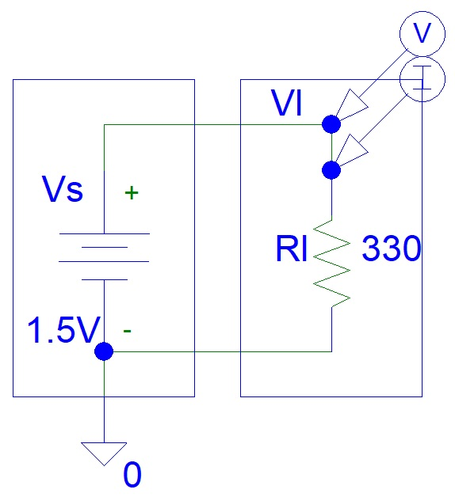
Figure 1: Ohm’s Law Circuit

3 Simulations

The circuit was simulated with PSpice software:
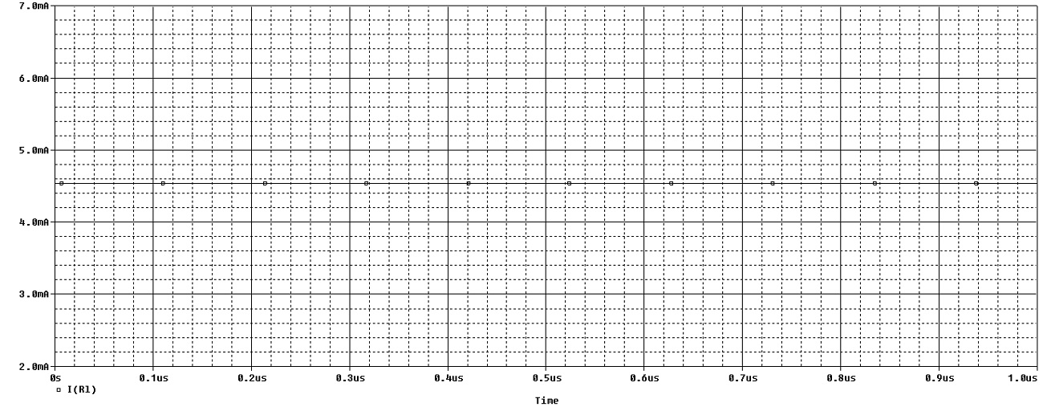
Figure 2: Simulations

We can now test Ohm’s law with Google online calculator:

I = V/R
= 1.5 V / 330 ohms
= 0.00454545455 A
= 4.54545455 mA

You can see that the calculations are very similar to simulated current results shown on the graph above (figure 2).

4 Conclusion

For DC analysis, ohm’s law is usually applied for resistors only because those are linear components. Using Ohm’s law to determine the currents and voltage of capacitors, inductors and semiconductors is a more complicated topic that is beyond the scope of this article.

Daphne Amplayo
Electronic Circuits Project

